**Task 2: Analysis and Specify Software Quality Requirements**

CloudTables-Service: a web interface for running on desktop or tablet computer for restaurant service staffs to help them providing services to the restaurant customers.

**Security and Privacy protection**

* Customer information should be secured via encryption and inaccessible to any unauthorised actors.
* Payment and sensitive information should be stored securely with strong security measures such as encryption and inaccessible to any unauthorised actors. The data should not be held any longer than necessary under GDPR regulations.

**Performance**

* Systems should be running at all operational times and levels to ensure that business can run smoothly.
* There should be minimal delays when using the system with no lag and no disconnection
* Service should not strain the hardware it runs on (e.g. efficient CPU and GPU usage)
* It should be possible to run multiple requests simultaneously without losing significant performance

**Reliability**

* The service must run at all times with regular maintenance and updates required to improve reliability
* A policy should be implemented in case of service going down
* Backups of the service must be regularly updated in case of service failure
* Service must be able to run even during other system failures

**Scalability**

* The service must be able to run for over 100+ clients
* Service must be able to store data for the 100+ clients
* Service must be able to increase the scalability over time to more clients
* Clients must have equally high performance service

**Task 3a: Use Case Model**

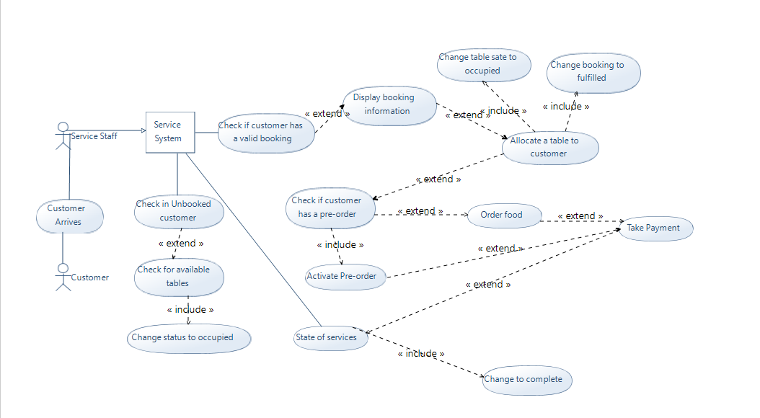

**Task 3b: Activity Model:**

**Use Case:** Order Food **Actors:** Service Staff, Service System, Customer

**Entry Condition:**

Customer orders food

**Exit Condition:**

Food is ordered and payment is made and state of service is updated.

**Flow of Events:**

1. Service staff asks customer to order food
2. Customer browses menu
3. Customer orders food
4. Services staff asks customer to review order
5. Customer reviews order
6. Customer confirms order
7. Service staff uses Service System to settle payment
8. Customer makes payment
9. Service staff uses Service System to update the state of services to complete
10. Customer and service staff exit system

**Exceptions:**

2) Customer doesn’t like any food options

* Customer exits system

5) Customer amends order

* Moves back to step 4

7) Customer fails to make payment

* System requests another attempt at payment
* If successful, move to step 9
  + Otherwise, customer exits system

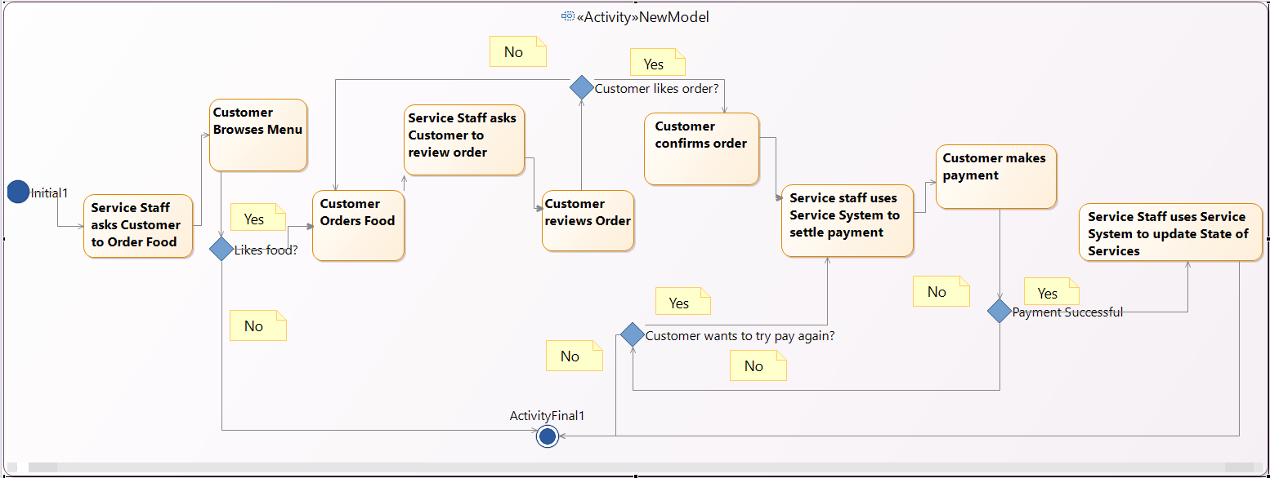

**Task 4a**

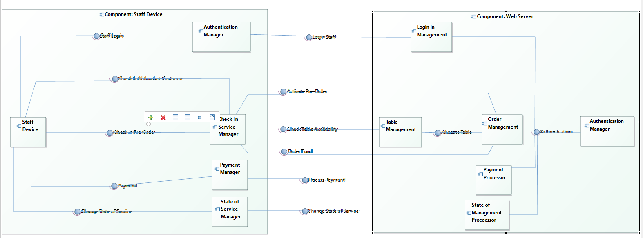

**Task 5a**

**Task 4b**